PRESS RELEASE

Tidetech’s new website and new product ‘Tidemap’

by David Shearer
13 July 2016

New Website

Tidetech Commercial Marine is very pleased to announce the release of its new website www.tidetech.org. The modern, simplified website is built on all-new infrastructure, meaning it is faster and easier to use. Our new user interface is scalable to modern mobile devices and is designed to support the user experience when you are “on the go”.

Let us know what you think at info@tidetech.org .

New Product ‘Tidemap’

‘Tidemap’ is Tidetech’s latest product release, set to revolutionise the way ocean data is viewed and applied to navigation and marine applications. Tidemap features advanced interactive mapping technology which provides detailed, high resolution tidal, ocean and weather forecasts suitable for use by marine and technical operations, for voyage optimisation and to assist with fleet management.

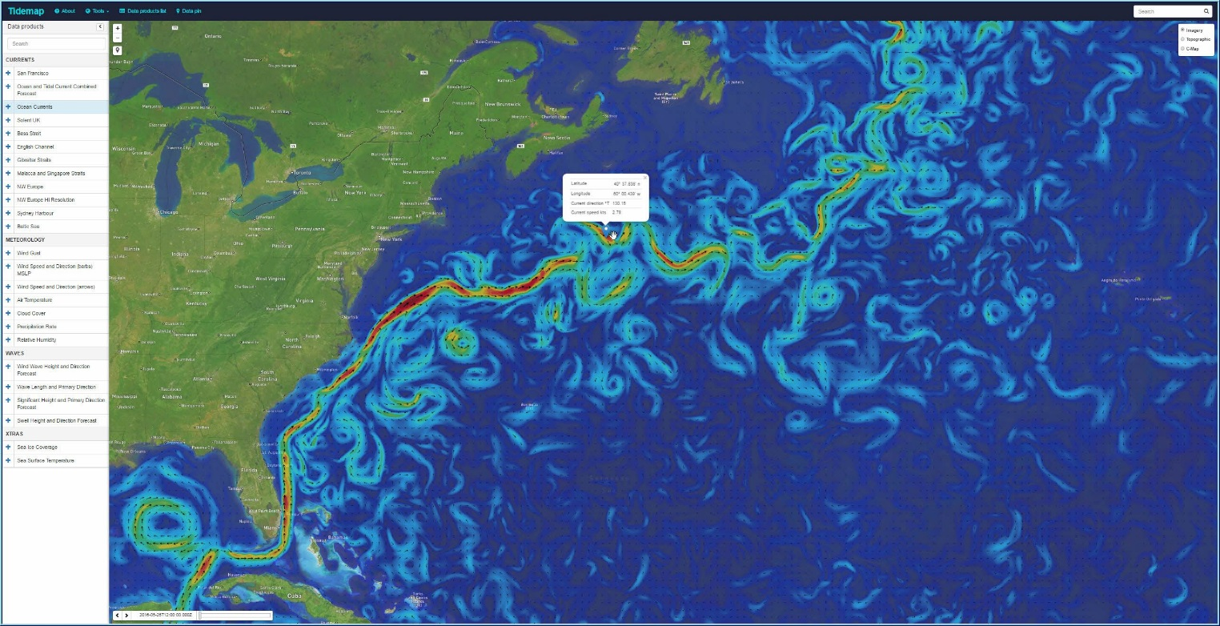

Tidemap’s easy-to-use, intuitive interface and can be accessed with ease on a mobile, tablet or desktop in any web browser. It is suitable for use on-board vessel for better informed passage planning and route management.

Access to Tidemap is free for a limited time. Click here to view Tidemap

Subscriptions are available from €9 per month for a single user licence. By subscribing to a Tidetech advanced licence, data can be downloaded in GRIB or NetCDF format for upload into navigation and passage optimisation software. Subscription details available here

About Tidetech

Tidetech provides detailed, accurate and validated metocean data including tidal and ocean currents, weather, waves, sea temperature and more for use by commercial shipping, maritime and competitive and recreational sailing.

Tidetech’s directors include former UK government research scientists, recognised by their peers as leaders in the field of physical oceanography. Tidetech’s team represents over 80 years of oceanographic research, ocean experience, and data management.

Contact

To learn more about this product, please contact:

David Shearer, General Manager
Tidetech Commercial Marine Pty Ltd
E: david.shearer@tidetech.org
P: +61 418 155 066
W: www.tidetech.org

